Project 3 (Family Tree Application)

Screenshot/Logo :
Landing page:
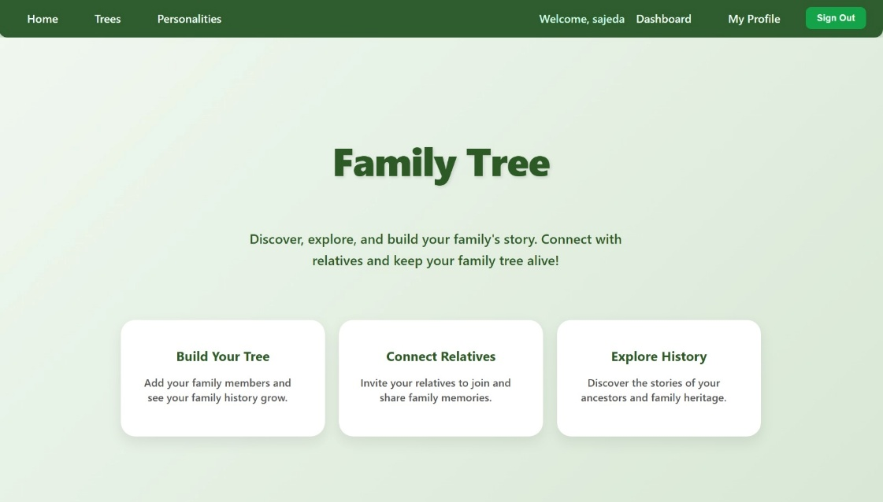
Dashboard :
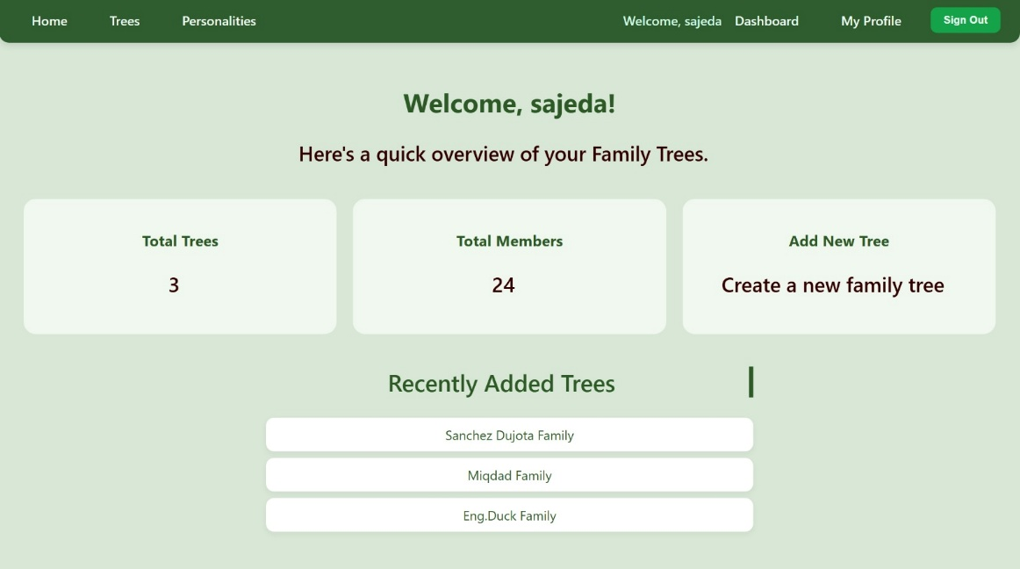

A Tree:
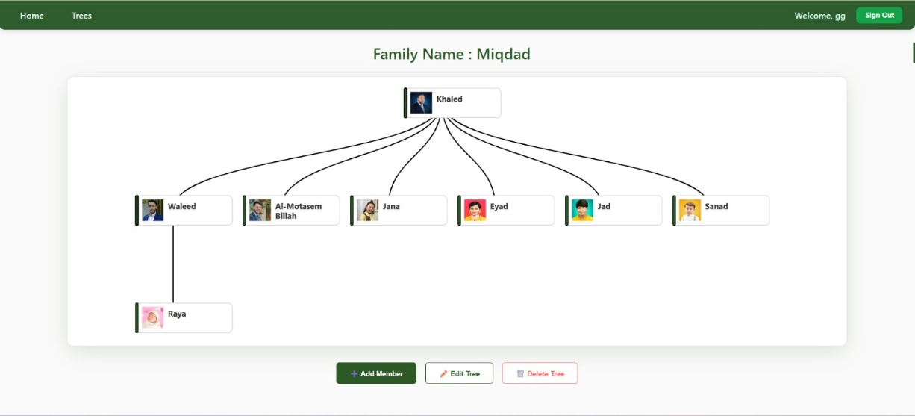
A profile page :
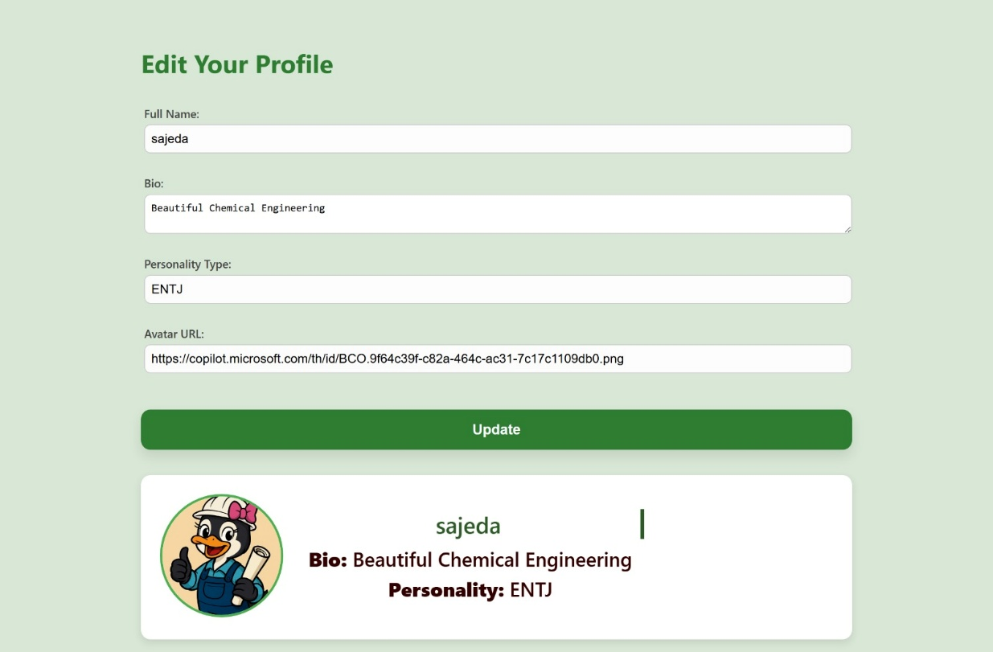

App’s name:
Family Tree Application.
The website allows users to create a family tree consisting of a group of members (“Grandparents", "Parents", "Son", "Daughter"). If the user is a member, he is allowed to view all existing trees, edit , and delete them. Members can also view all members within a single tree, edit their information, and delete them. However, if the user is not a member, they will only be able to view the available data.
Getting started:
Link to the planning materials:
"C:\Users\Asus\code\ga\projects\Family-Tree_Frontend\src\assets\family tree ERD.jpeg"
Link to the back-end repository : (https://github.com/SajedaHussain/Family-Tree-Backend/tree/main)
Link to the front-end repository :( https://github.com/SajedaHussain/Family-Tree_Frontend.git)

Attributions:
external resources such as libraries or assets.
- libraries used :
- react-d3-tree
- sweetalert2

Technologies used:
- JavaScript.
- HTML.
- CSS .
- JSC.
- JSX
- Google Gemini

Next steps:
Planned future enhancements :
- If we had more time, we would add colors to the node borders — pink for girls and blue for boys — and make twin nodes connected together.
- Add a search bar for finding the family trees easier .
- Using API to get the information for different personality type.

